# FEIPS Conference

# Resilience

# Wednesday 1 May 2019

A CPD event to enhance and revitalise your FEIPS practice, share your work and support each other as well as an opportunity for those who aren’t currently FEIPS trained to gain an insight into the work and to enhance their own work with children and young people.

**Location**: Alton area **Total cost**: £100 per particpant (to include buffet lunch)

# Key Note Speakers

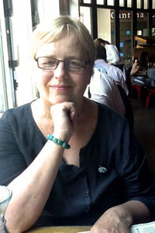**Maddie Burton – Piecing the puzzle together; Resilience and Risk, Adverse Childhood Experiences (ACEs), Child and Adolescent Mental Health….**

Maddie has co-authored *Children’s Mental Health and Emotional Well-being in Primary Schools: A Whole School Approach* (Howard, Burton, Levermore and Barrell, (2017). *An Introduction to Child and Adolescent Mental Health* (Burton, Pavord and Williams 2014). Alongside chapters in *Essentials of Mental Health Nursing* (eds., Wright and McKeown, 2018), relating to child and adolescent mental health and supporting people with eating disorders.

Maddie is a Registered Mental Health Nurse and for several years worked in both inpatient and community Child and Adolescent Mental Health Services. Maddie is Senior Lecturer in Child and Adolescent Mental Health at the University of Worcester.

Maddie continues to maintain close links with CAMHS practice and works with both schools and student teachers at the University of Worcester from a CAMH perspective. Her research interests include: promoting children and young people’s rights, infant, child and adolescent mental health, and the development of current and future practitioners who work with children and young people. Her interests also include improving CAMH knowledge and understanding how it links and impacts on children and young people’s lives, practice outcomes, particularly in school, early years and other universal settings.

**David Tipper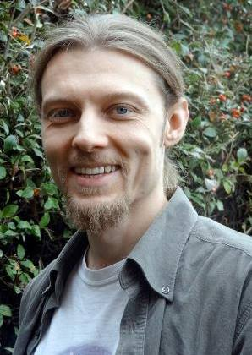.** Our afternoon speaker will be David Tipper. David is a practising sound therapist and teacher of yoga and mindfulness. As a sixth form teacher at Barton Peveril College he also has a keen interest in supporting health and wellbeing within the education context. The practice of sound therapy is not a new concept although has very much come into common practice in recent years. Therapeutic sound can be practiced on a 1:1 level or within groups; it can even be applied as a life skill for healthy living. By using specific sounds of varying tone and frequency (instrumental or voice) it is possible to influence both mental and physical wellbeing. This is often practiced using the popular ‘sound bath’ approach which allows the mind and body to deeply relax and unwind through the immersion of healthy sound. It also has the benefit of being applicable and accessible to anyone so is particularly useful for when working with people with disabilities or health problems. David’s session at the FEIPS conference will provide an overview of the approaches, application and effects of sound therapy. You will have the chance to experience some of the methods used in therapeutic practice and begin to explore your own relationship with sound.

# Workshops

Participants will be able to attend two workshops designed to develop and extend their FEIPS work (more information on the workshops will be sent out nearer the time). The workshops will be facilitated by our key note speaker, Maddie Burton and by members of the FEIPS team (EPs and therapists). These workshops will include; creative use of the sand tray, use of Kinetic Family Drawings, ‘Starting and Stopping’ – a focus on the challenges, significance and practice of beginning and ending FEIPS sessions. Maddie’s workshop will be ‘unpicking (or making sense of) children and young people’s stories and experiences using case studies, genograms and timelines’.

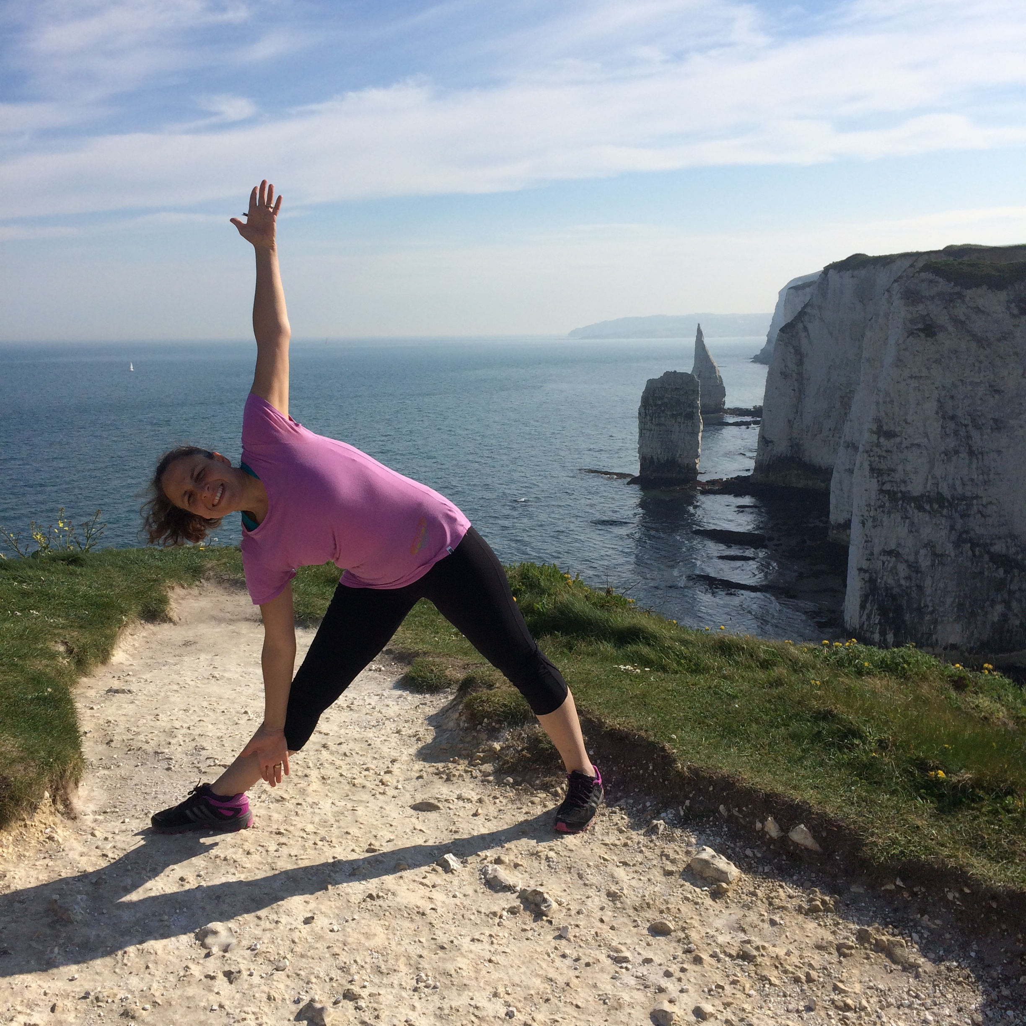

We also have special guest Level 2 Yoga Alliance teacher Marzia Stefani coming to facilitate a workshop called ‘The art of bouncing- back: ancient Yogic principles to build resilience in the 21st century'

This will be an interactive workshop comprising practical advice on how to use yoga and mindfulness to develop resilience in both the children you support and FEIPS members. Expect to explore breathing techniques, Yoga poses as well as the power of affirmations.

To book a place, please complete the form overleaf and return by: **Friday 5th April 2019.**

**Please note places are on a first come, first served basis.**

Early Bird Booking – book before 9th March and get an extra place for a FEIPS or non-FEIPS practitioner, at a reduced rate of £50 (£150 for two people from the same school).

**17430689**

